Sugarloaf School Virtual Instruction Tech Support for Parents/Students and Staff

All students can access materials and class information by following the directions below.

Students should login via

Launchpad.classlink.com

Login is login ID (first initial last name) and password is 44Lunch#0

*District issued Chromebook should auto load the classlink/my.keysschools.com page*

All students will initially access all class components via Google Classroom.
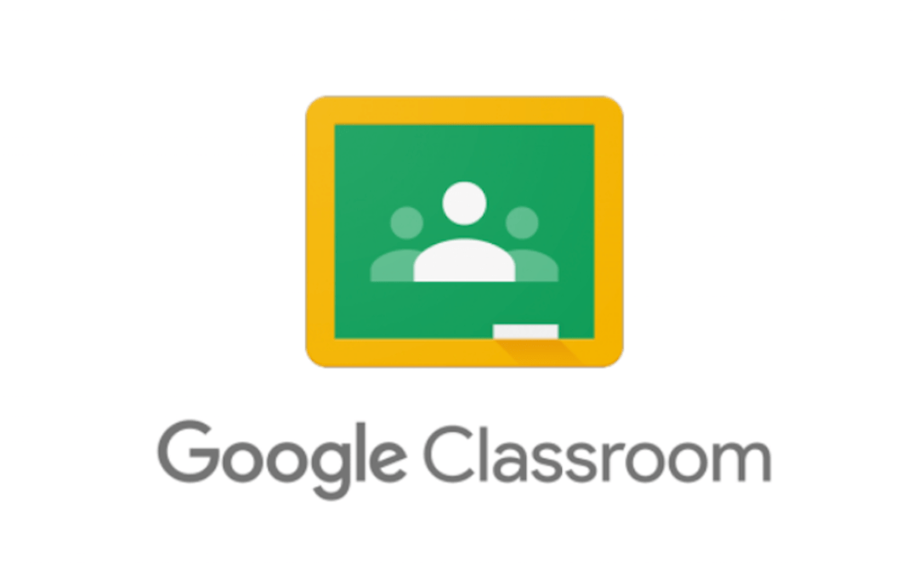

The Contacts below can be additional resource for questions or support that you many need while navigating the virtual platforms. Parents and Students, please check with your teacher first since they may be able to answer your question as well.

Kevin Walden: Google Education Suite Support and overall Technology Support
Kevin.walden@KeysSchools.com
PH. (786) 475-4469

Alena Ellerbee: Nearpod Platform, and overall Technology Support
Alena.Ellerbee@KeysSchools.com
PH. (305) 563-7326

Marissa Means: Google Education Suite Support and Ebooks
Marissa.Means@KeysSchools.com
PH. (786) 503-0977

Antoine Massih- SLS IT technician: District Issued Device / Technical Support -Usernames/passwords* Please note if you have connectivity issues check with your internet provider first.
Antoine.Massih@KeysSchools.com
PH. (305)-745-3282 ext. 50314

Additional Resources
- Parent/Student Focus Portal and Instruction Information
- Google Classroom Parent/Student Support Video
- MCSD Technology Usage Policy
- Student and Parent Tutorials
- MCSD Parent Website: https://sites.google.com/view/parentsmcsd/home
- MCSD Instructional Materials and Digital Tools
https://sites.google.com/keysstudents.net/mcsd-technology-integrations-2/home

