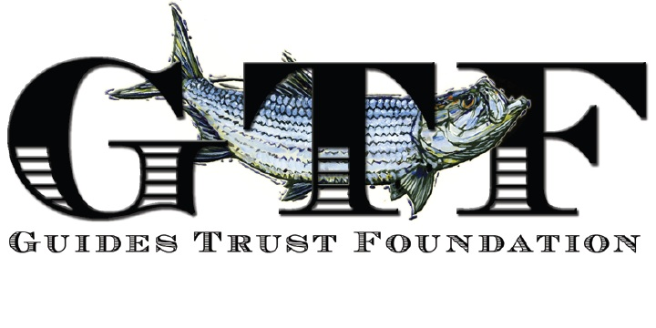

DATE: January 30, 2025

TO: College Guidance Counselors
Key West High School
Marathon High School
Coral Shores High School

FROM: Guides Trust Foundation, Inc. (“GTF”)

SUBJECT: Scholarship Opportunities

GTF is pleased to announce that it will be awarding one or more $5,000 scholarships to deserving students who will be (i) graduating from a Monroe County High School in the Spring of 2025 and (ii) attending their chosen college / university in the fall of 2025.

Qualified students who will be pursuing a bachelor’s degree in marine science, marine biology, marine resource management, environmental studies or other related majors are encouraged to apply. This is a merit-based scholarship.

Completed applications (including any attachments thereto) must be received by GTF no later than April 15, 2025 – and can be delivered either (i) by mail to Guides Trust Foundation, Inc., P.O. Box 88, Islamorada, FL 33036 or (ii) via e-mail to gtrustfoundation@gmail.com. Award recipients and their guidance counselors will be notified on or about May 10, 2025.

If you or the student applicants have any questions re. the application itself or the application process, then please contact Terry Nickels via phone (305-304-9522) or email (gtrustfoundation@gmail.com).

Sincerely,

Evan Carruthers
Evan Carruthers
GTF Chairman

