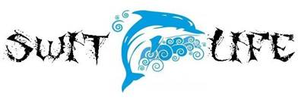

SAC Meeting Agenda April 18, 2018
Media Center 5:30pm

1. Wesley House Representative

2. Calendar Review

3. FSA Schedule:
PBT-April 24 & 25: 3rd grade reading
CBT-April 26 & 27: 5th math
CBT-May 1 & 2: 4th grade reading
CBT-May 3 & 4: 5th reading
CBT-May 8 & 9: 3rd grade math
CBT-May 10 & 11: 4th math
PBT-May 15 & 16: 5th science

4. Summer School- Switlik campus will be closed.

