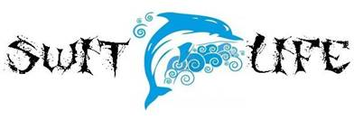

SAC Meeting Agenda April 18, 2018
Media Center 5:30pm

1. Wesley House Representative- Caitlin Bourassa spoke about the need for foster families in the keys. They currently only have seventeen foster families throughout the keys and they are in great need for more. She passed out flyers and asked us to please send anyone that is interested to her and she will guide them on how to become a foster family.

2. Calendar Review- Assistant principal Mrs. Rodriguez reviewed the calendar and important events that are coming up. She also reviewed the FSA dates for each grade level.

3. FSA Schedule:
PBT-April 24 & 25: 3rd grade reading
CBT-April 26 & 27: 5th math
CBT-May 1 & 2: 4th grade reading
CBT-May 3 & 4: 5th reading
CBT-May 8 & 9: 3rd grade math
CBT-May 10 & 11: 4th math
PBT-May 15 & 16: 5th science

4. Summer School- Switlik campus will be closed.- Principal Brett Unke discussed the construction process that’s going to begin over the summer. The office will be moved to the MHS campus for the summer as well as our summer school program.

