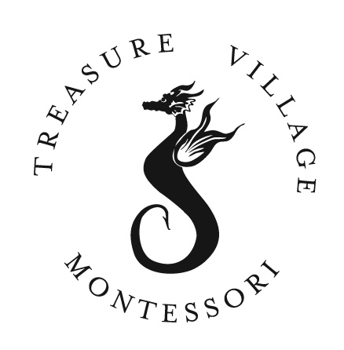
Grade 4/5 Science Syllabus
Treasure Village Montessori
86731 Overseas Highway Islamorada, FL 33036
(305) 852-3482 Fax: (305) 852-2432
Treasurevillagemontessori.com
Instructors: Ms. Cathy and Ms. Hess
Email: Cathy.gwilliam@keysschools.com and Debra.hess@keysschools.com

Philosophy:

Science is designed to give students an understanding and appreciation of the world around them, their affects upon it and it’s affects upon them. Our science curriculum focuses on learning science skills through the study of the physical, earth and life sciences. Physical Science takes a look at matter and energy in our world around us. Earth & Life Science explore the Solar System and the structure and function of the Human Body. By using hands on experiments, supplemental videos, content vocabulary and reading, the students will discover and understand many of the scientific concepts.

Expectations:
- Physical Science
- Force and Motion: Students will be able to explain the relationship that exist among mass, force, and distance traveled.
- Energy: Demonstrate the difference between potential and kinetic energy.
- Earth Science
- Cycles: Water Cycle, Nitrogen Cycle, Co2/02 Cycle
- Weather: Analyze how weather and climate are affected by landforms and bodies of water.
- Earth/Moon/Solar System/Sun: Distinguish among the planets according to their known characteristics such as appearance, location, composition, and apparent motion.
- Forces that change the Earth-Landforms: Compare how volcanoes, earthquakes, faulting, and plate movements affect the earth’s surface features.
- Resources: Understand the difference between Renewable, Nonrenewable, Fossil Fuels.
- Life Science
- Life Cycles of Plants & Animals: Compare and contrast the basic structures and functions of plant and animal cells.
- Adaptations of Plants & Animals: Illustrate how an animal’s physical characteristics enable it to survive in a particular environment.
- Ecosystems/Habitats/Food Chain & Food Web: Evaluate producer/consumer, predator/prey, and parasite/host relationships. Classify specific relationships within an ecosystem as mutualism, commensalism, or parasitism.
- Genetics: Explain how genetic information is transmitted from parents to offspring.

Lab Expectations:
Laboratory investigations and hands-on activities are an essential part to learning science. The following procedures have been set-up to insure your child, as well as his/her classmates, are in a safe environment. Each student will be instructed on laboratory safety and procedures. We will be asking for donations of materials from time to time. Items will be inexpensive but necessary for the experiments. Misbehavior during lab can result in immediate termination of the student’s participation in the lab, a grade of zero, and a phone call to parents.

Materials:
SRA Science Lab
Interactive Science Notebook
Montessori Materials
STEM
EIE
Grading:
- 100%-90% - A
- 89%-80% - B
- 79%-70% - C
- 69%-60% - D
- 59% and below – F
Turning In Assignments
Work will be collected by the teacher on assigned due date. Teacher has ability to make changes to the due dates.

Student Responsibilities After An Absence
If you are absent for any reason, you will need to make up the work you missed for credit. You are allowed one day for every day you are absent to turn in missed work, if the assignment was not a long standing assignment. If there was any work that you missed, you can touch base with the teacher. It is the responsibility of the student to check and turn in the missed assignments.

Late, Missing or Incomplete Assignments
Late work will go down 10% for every day it is late until it reaches 50%. You cannot get lower than 50% on any of the assignments you complete. I believe that half of the assignment is in the time and effort you spend to complete it.

Missing work will not receive any credit and will be a zero in the grade book. You may turn in any work that is missing as long as we are still studying that concept or unit. Previous unit work will not be accepted.

Assessments:
Fifth graders take the science assessment in the spring.

Communication:
Teacher can be contacted via email (preferred) or by leaving a message with Ms. Amanda in the Front Office. Please allow 24 hours for us to respond.

Enrichment/Remediation:
Students with an IEP (Individualized Education Plan) will be given specific accommodations within the classroom and on assignments. If you have questions or concerns about your child’s specific accommodations please email or call to make an appointment.

Resources for Home Use:
Study Island

